

**Bachelor of Science in Computing**

**School of Public Administration**

**Macao Polytechnic Institute**

**COMP 492 Final Year Project**

**Progress Report**

|  |  |
| --- | --- |
| **Indoor Helper Robot** | |
|  |  |
| Project Number: | 29 |
| Student Name: | Key, Liang Yijuan  (p1107923) |
|  |  |
| Supervisor: | Dr. Cora Lai |
| Assessor: | Dr. CT Lam |
|  |  |
| Submission Date: | 2014/04/17 |

Contents

**Declaration of Originality** 3

**Abstract** 4

**Acknowledgement** 5

**1. Main tasks and Objectives** 6

**2. Project Description** 6

**3. Summary of Related Work and Key References** 7

**4. Project Workplan** 8

**5. Risk Assessment** 9

**6. Reference** 10

# **Declaration of Originality**

I, Liang Yijuan, declare that all the contents in this report was written by me originally. All the reference contents were cited in the end.

# **Abstract**

This report presents an indoor robot using LEGO® MINDSTORMS® EV3 as the basic hardware. Indoor positioning with Radio Frequency Identification RFID and landmark recognize technology is used in the project. The pass similar projects are analysis in the first month of the project. Different localization approach tried in the analyzed projects will be tried to re-present in the LEGO robot which the hardware is not built up by the author of a project. Also, an android application will be develop in the project for reading the RFID tags.

# **Acknowledgement**

I want to express my greatest appreciation to my project supervisor Dr. Cora Lai. She spent a lot of effort to help me with my project and writing. I also want to say thank you to Prof. Giovanni Pau and Prof. Rita Tse shared the biggest support for the hardware. Without the above three people, I could not image the project would develop to the final stage.

# **1. Main tasks and Objectives**

The main task of this project is to develop and control an indoor navigation robot which can go to a desired place within a room area and do the delivery as a helper. This robot can move following the color line and fetch objects and do delivery. LEGO® MINDSTORMS® EV3 is chosen as the development model.

The following functions should be developed with the robot in this project:

* Move from starting position to different destinations
* Move according color lines
* Turn left or right correctly
* Go back to start area after reaching the destination
* Read NFC tags to recognize places
* Fetch and deliver objects

# **2. Project Description**

In this project the following tasks should be done before the end of next semester.

* Study related works
* Experiment how to place the different sensors
* Experiment how to place NFC tags
* Experiment fetch and deliver different objects
* Design fuzzy logic for movement
* Recognize different color and run action correctly
* Develop a moving road database
* Design the program
* Implement the program
* Writing the report

The following table shows the scope of this project:

|  |  |
| --- | --- |
| Function Provided | My project |
| Color sensing | **√** |
| NFC positioning | **√** |
| Move following the line | **√** |
| Fetch objects | **√** |
| Deliver objects | **√** |
| Move in a room | **√** |
| Move in the same floor | **×** |
| Move in different floor  **Figure 1 Project scope** | **×** |

As confined by the Bluetooth signal range, the robot in this project will move in room A322 in MPI, but not move around the whole floor. In the very beginning, this EV3 robot will move on a whiteboard following color landmarks drawn with highlight pens.

# **3. Summary of Related Work and Key References**

As the development of technology, human interactive robot development has been a big topic in the world. Developing a robot helper instead of human do by themselves has been a trend of people’s interests. Fuzzy logic design, which is introduced in 1960s, will be also used as other similar robot projects. LEGO® MINDSTORMS® EV3 programmable robot is chosen for this project because it is small enough to move and carry. Also, spare parts are available to be used to develop extra original modules as well because only a few of provided parts are used to build up the basic model this robot of LEGO® MINDSTORMS® EV3. Moreover, added sensors are also available in the LEGO® official website. And this EV3 robot also supports different kinds of connection means including Wi-Fi (but this requires an added Wi-Fi adaptor). Therefore, it is well famous to be selected in similar kinds of projects. Similar works is also done by many people. In 2007, the article *Fuzzy Logic Controlled Miniature LEGO Robot for Undergraduate Training System* [1] is published by IEEE. Besides, *Color Landmark Based Self-Localization for Indoor Mobile Robots* [2]is also publish in Korea. In this project fuzzy logic will be also designed but color recognize will simple read color landmark and Radio Frequency Identification (RFID) technology will also use for positioning.

Mobile robot with RFID sensors have been raise in the last decade. [3] Tasks like navigation, localization and mapping can be done with information inside a RFID tags. [4] Evidences can be easy found in many projects. For example, Gueaieb, W and Miah Md.S. presented an intelligent novel non-vision-based robot using RFID technology. [5] In their project, the robot was attached with two RFID antennas which was used to recognize RFID tags on the moving path for controlling the moving of the robot. In the whole process three stages of experiments was shown. All the stages were using a RFID reader attached with the robot and read tags from the moving path. In the development of the whole project, the robot was firstly tried to move following a line segment, and then tried to move following a complex path. After successfully try with the two approach and then the third experiment—moving following tags singles from the hallway is done successfully. The author considered that it is the first algorithm for tracking both a target position and a desired trajectory with an RFID system. Besides the above project, HyungSoo L et al. [3] presented an indoor robot using an efficient RFID system which a scheme for the efficient localization is designed. RFID tags with absolute position information were attached on the floor for localization in the project. Hahnel, D et al. [4] analyzed Radio Frequency Identification (RFID) could be implemented to for a better mobile robot localization.

What’s more, a mobile robot which can navigate in a known environment is developed by Hallmann and Siemiatkowska. [6] 16 sonars, 16 infrared sensors, an onboard Pentium computer, and a gray-scale camera is equipped with the robot. In this project, information on a map of the environment to be tested is built inside. The built map is developed based on information feedback from the sonar and sensors. Landmarks was also placed in specific locations to help with the navigation. This is a combination of using both RFID and landmark for a better robot localization.

# **4. Project Workplan**

The schedule of all the works are shown in Figure 2

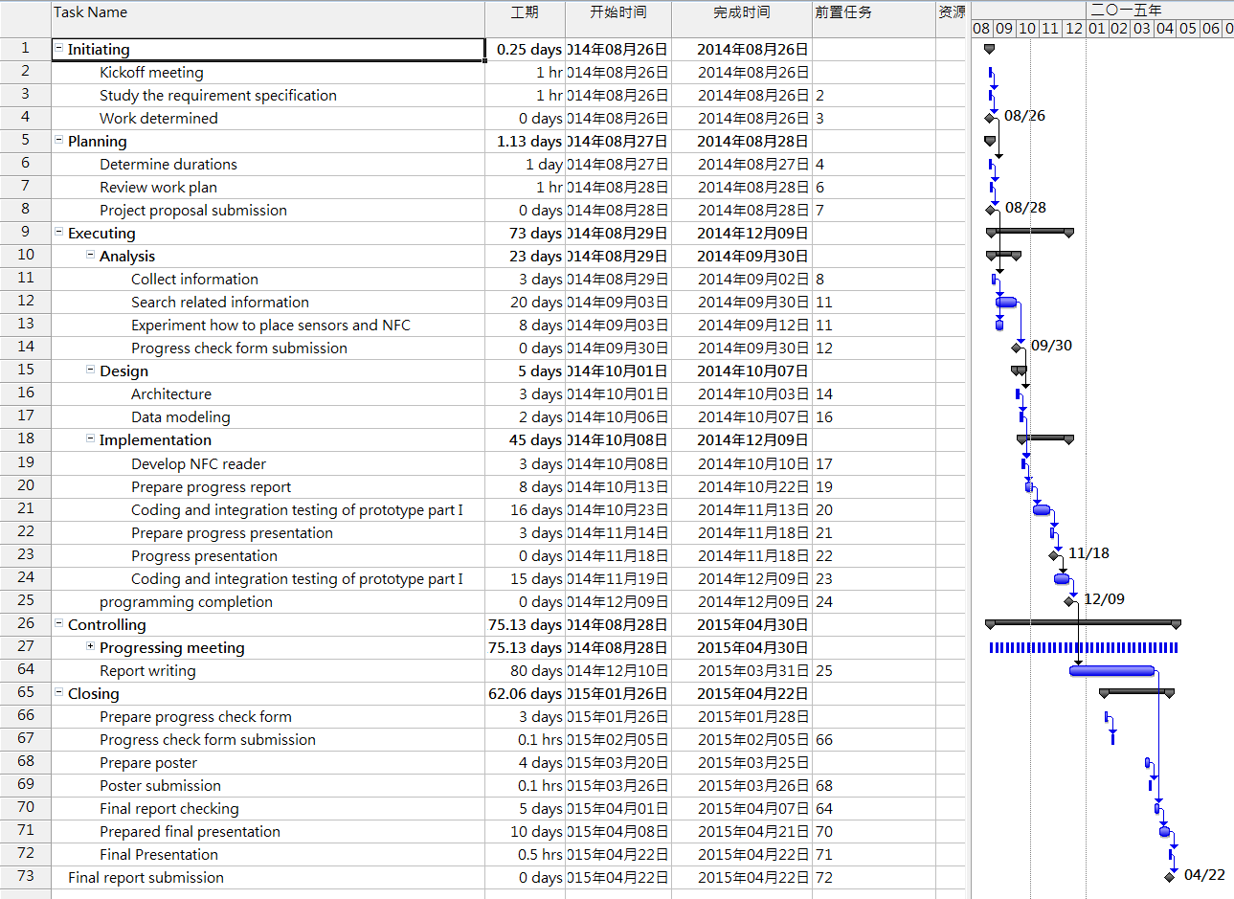

**Figure 2 Work plan**

# **5. Risk Assessment**

During the process, there are four possible risks may occurs, namely battery running out, connection setup disabled, harddisk damage and data lost and motor out of function.

* Battery running-out
  + Firstly, there is a potential risk that battery runs out during the testing period. This will lead the robot unable to move properly. Also, as movement is controlled by the motor volume, so if the battery is almost run out and cannot provide enough power for moving distance as the design. Therefore, full-charged backup batteries are prepared.
* Connection setup disabled
  + Secondly, as there are too much radio signals in the campus, Bluetooth connection may be interfered. This makes it impossible to set up the connection between the computer and the robot. If this happens, it is tested to be feasible to move to another place, for example the rooftop, to reset the connection. The connection set up process can be performed at the rooftop of the teaching building, as there is less interferes. Once the connection is set up it will not be disconnected until disconnect operation is triggered, and after connection set up, everything can be move back to the lab and resume its normal operation.
* Hard disk damage and data lost
  + Thirdly, all the develop programs or documents may lost due to hard disk problem. Therefore, besides saving data in the local computer, at least one copy backup will be placed in a USB and a backup copy will be put in the network. Once development data is lost, backup data will be used to continue the project. Furthermore, all files of the every process will have at least one backup copy so that the project can go back at any time.
* Motor out of function
  + Last but not least, In case of accident, motor of the robot may be out of function. This might stop the robot from moving. If this happen, it is necessary to replace motor with a backup that is in place.

# **6. Reference**

[1] Azlan, N.Z.; Zainudin, F.; Yusuf, H.M.; Toha, S.F.; Yusoff, S.Z.S.; Osman, N.H., "Fuzzy Logic Controlled Miniature LEGO Robot for Undergraduate Training System," Industrial Electronics and Applications, 2007. ICIEA 2007. 2nd IEEE Conference on, vol., no., pp.2184, 2188, 23-25 May 2007

[2] Gijeong Jang; Sungho Lee; Inso Kweon, "Color landmark based self-localization for indoor mobile robots," Robotics and Automation, 2002. Proceedings. ICRA '02. IEEE International Conference on, vol.1, no.,

[3] Klaus Finkenzeller. RFID Handboook: Radio-Frequency Identification Fundamentals and Applications. Wiley, New York, 2000.

[4] Hahnel, D.; Burgard, W.; Fox, D.; Fishkin, K.; Philipose, M., "Mapping and localization with RFID technology," Robotics and Automation, 2004. Proceedings. ICRA '04. 2004 IEEE International Conference on , vol.1, no., pp.1015,1020 Vol.1, 26 April-1 May 2004

[5] Gueaieb, W.; Miah, Md.S., "An Intelligent Mobile Robot Navigation Technique Using RFID Technology," Instrumentation and Measurement, IEEE Transactions on , vol.57, no.9, pp.1908,1917, Sept. 2008

[6] I. Hallmann and B. Siemiatkowska, “Artificial landmark navigation system,” in Proc. Int. Symp. Intell. Robot. Syst., Jul. 2001, pp. 219–228.